Parents help sheet - accessing google classroom.
Follow the link below

https://www.c2kschools.net/

Children log in using their normal username and this will open my school home page.

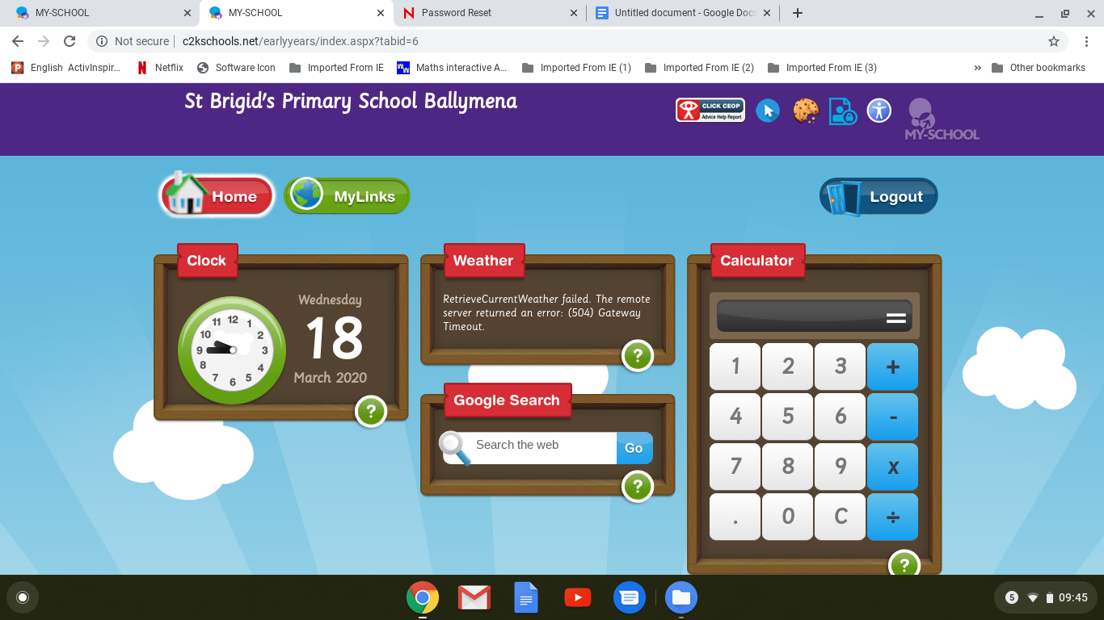

Choose my links

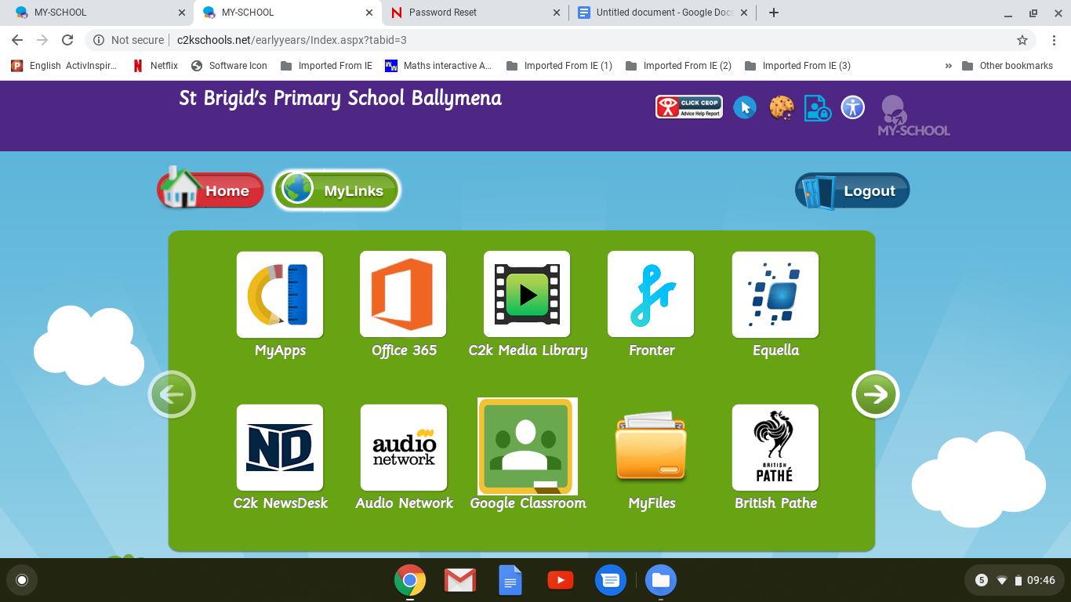
Click on google classroom

The pupil will need to log in to google using their

username@c2ken.net (username is normal school log in name)

Followed by the children’s normal school password.

When google classroom is open choose the small plus icon at the top and “join class”.

Enter the code for the class provided by the teacher.

